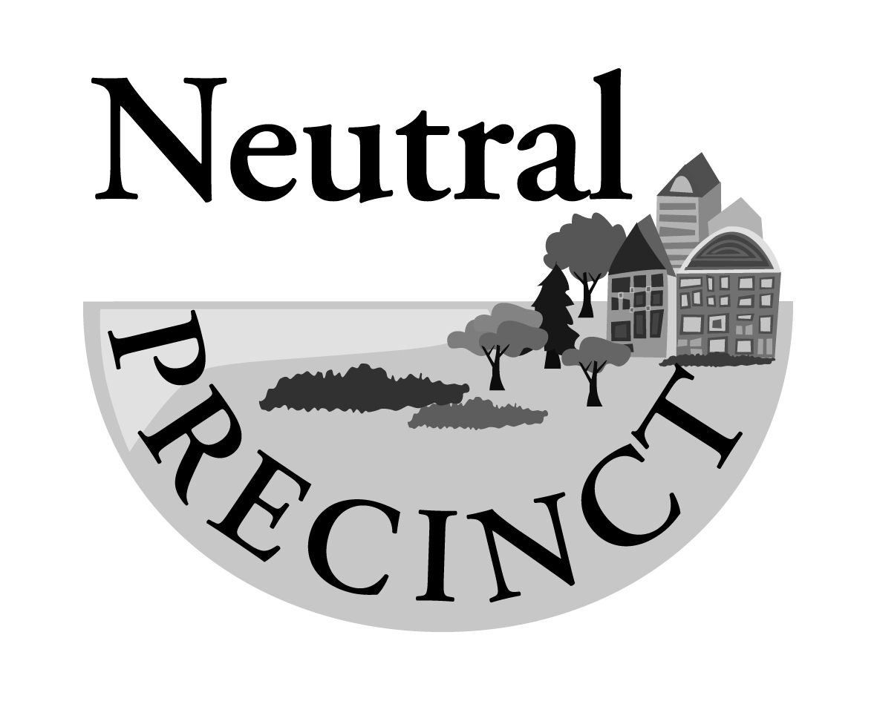
Precinct Meeting
Tuesday 14 MARCH at 7.00pm

Neutral Bay Club
(3 Westleigh Street Neutral Bay)

COME AND MEET THE MAYOR + Q & A

North Sydney Mayor Zoe Baker will discuss Council’s new Neutral Bay Town Centre Planning Study and take your questions on other issues currently impacting Neutral Bay.

Followed by our March meeting

AGENDA

- Business from minutes of meeting held 14 February

- Update: Planning Proposal 1/23 1-7 Rangers Road (Woolworths)

- Planning Proposal 12-14 Waters Road, Neutral Bay (DPE-led public exhibition, submissions close 22 March

- Update: Warringah Freeway Upgrade

- Discussion: Merger of Neutral, Hayes & Kurraba Precincts?

- Development Applications
Precinct Minutes and Summary of Actions are available on Council website: https://www.northsydney.nsw.gov.au/neutralprecinct

HAVE YOUR SAY
Your Say North Sydney is Council's online engagement portal. The portal houses all public exhibitions. See here for all current and past engagements:
https://yoursay.northsydney.nsw.gov.au

Cremorne Plaza & Langley Place upgrades - closes 3 April
The Cremorne Plaza and Langley Place upgrades are the last sites to be upgraded in Council's Neutral Bay and Cremorne Public Domain Upgrade Masterplan (2015). Following the preliminary feedback period, revised draft design options are now on public exhibition for feedback.

- Drop-in Info Stall 1 - Wednesday 1 March, 2pm - 4pm
- Site Walkthrough - Wednesday 8 March at 4pm with Council staff and design consultants
- Design Workshop - Wednesday 22 March places limited; registration essential
- Drop-in Info Stall 2 - Monday 27 March, 4pm - 6pm
https://yoursay.northsydney.nsw.gov.au/cremorne-plaza-langley-place-public-domain-upgrades

Neutral Bay Town Centre Planning Study - early engagement

Council is preparing a Planning Study to help manage and influence positive changes to the Neutral Bay Town Centre. The NBTCPS will guide future development proposals within the centre which may include targeted modest increases in height and density while retaining the village atmosphere.

• better manage the development pressures within a consultative and informed development framework
• create an opportunity to improve the public domain and local facilities
• strike the right balance between public benefits and any additional density or building height
• retain and strengthen the employment opportunities within Neutral Bay

https://yoursay.northsydney.nsw.gov.au/nbtcps

